

Group: C1.010

López Cubiles, Antonio José - [antlopcub@alum.us.es](mailto:antlopcub@alum.us.es)

February 16th, 2024

PLANNING AND PROGRESS Report

**Repository: https://github.com/C1-010/Acme-SF-D01**

Contenido

1. Executive Summary 2

2. Revision Table 2

3. Introduction 2

4. Contents 3

4.1. Planing chapter……………………………………………………………………………………………………..3

4.1.1. Tasks………………………………….…………………………………………………………………..3

4.1.2. Screenshots………………………….………………………………………………………………..4

4.1.3. Budget…………………………………….…………………………………..…………………………5

4.2. Progress chapter……………………………………………………………………………….……..……………6

4.2.1. Progress records……………………………….………………………………………..………….6

4.2.2. Conflicts…………………………….…………………………………………..………………………6

4.2.3. Costs comparison…………………………….…………………………………………..………..6

5. Conclusions 7

6. Bibliography 7

# 1. Executive Summary

In this document I will showcase thew planning of the D01 deliverable, with all its tasks, estimated and real development times, estimated budgets and real costs and screenshots of the process.

# 2. Revision Table

|  |  |  |
| --- | --- | --- |
| Revision number | Date | Description |
| 1 | 16/02/2024 | Initial Version |

# 3. Introduction

This document is a report of the planning and progress of a specific deliverable. It encapsulates the meticulous planning process undertaken to fulfill the requirements of the deliverable and its progress.

In the planning chapter, I will provide a detailed listing of tasks completed to meet the deliverable's requirements, showcasing the task titles, descriptions, assigned personnel and roles, expected versus actual development time. Additionally, screenshots of the process are included, adhering strictly to the working methodology prescribed in lesson "S03 - Working together". Also, there is a budget estimation, showing the total estimated cost required for a task’s completion, estimated hours and personnel costs per role, as well as amortization costs.

In the progress chapter, a listing of progress records is presented, indicating the performance indicators defined in the project charter. This quantifies progress and also shows the quality of the work, distinguishing between good and bad performance. Furthermore, any conflicts encountered during the execution phase are described, along with the strategies employed to address them. Finally, a comparative analysis between the initially estimated costs and the actual costs incurred upon completing the deliverable is provided.

# 4. Contents

**4.1. Planning chapter**

**4.1.1. Tasks**

**Task 001**

**Description:** Modify the anonymous menu so that it shows an option that takes the browser to the home page of your favourite web site. The title must read as follows: “〈id-number〉: 〈surname〉, 〈name〉”, where “〈id-number〉” denotes your DNI, NIE, or passport number, “〈surname〉” denotes your surname/s, and “〈name〉” denotes your name/s

**Role/s:** Developer

**Planned time:** 10 min.

**Actual time:** 6 min.

**Task 011**

**Description:** Produce an analysis report.

**Role/s:** Analyst

**Planned time:** 30 min.

**Actual time:** 26 min.

**Task 012**

**Description:** Produce a planning and progress report.

**Role/s:** Analyst

**Planned time:** 40 min.

**Actual time:** 29 min.

**Task 001T**

**Description:** Review the documents written for this deliverable and look for mistakes.

**Role/s:** Analyst

**Planned time:** 15 min.

**Actual time:** 8 min.

**Task 002T**

**Description:** Test the functionality of the developed code and fix any last error.

**Role/s:** Tester

**Planned time:** 5 min.

**Actual time:** 3 min.

**4.1.2. Screenshots**

Initial definition of all tasks in the "to do" lane.

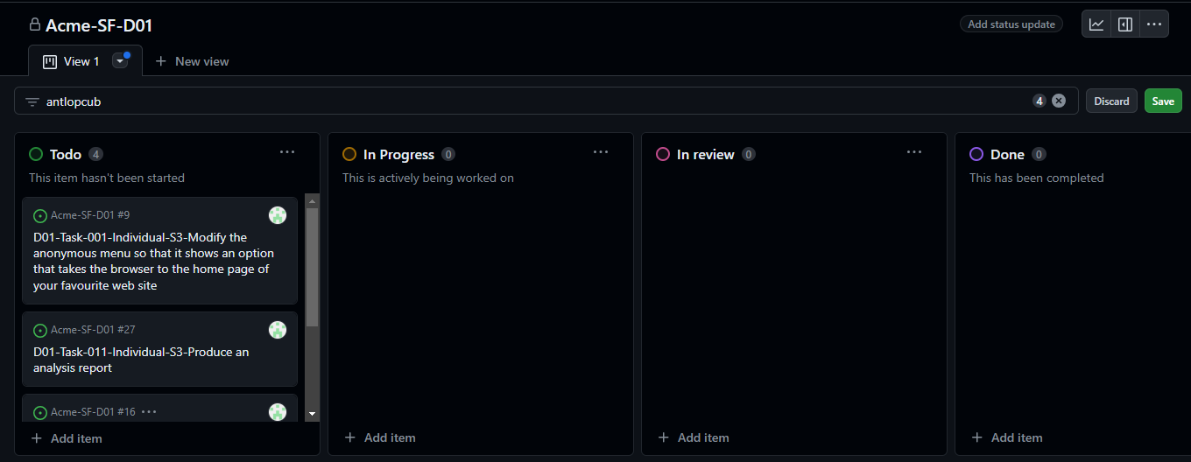

Screenshot in the middle of the delivery.

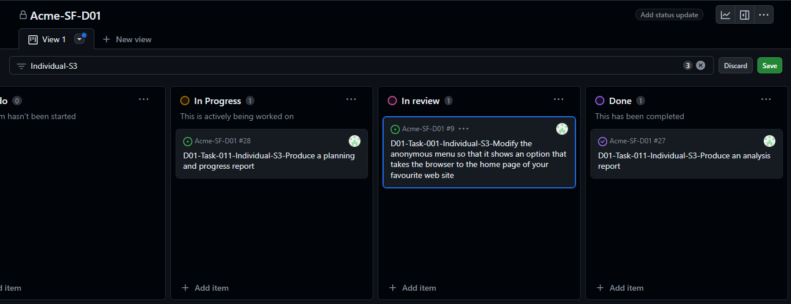

Screenshot in the end of the delivery showing all tasks in the "done" lane.

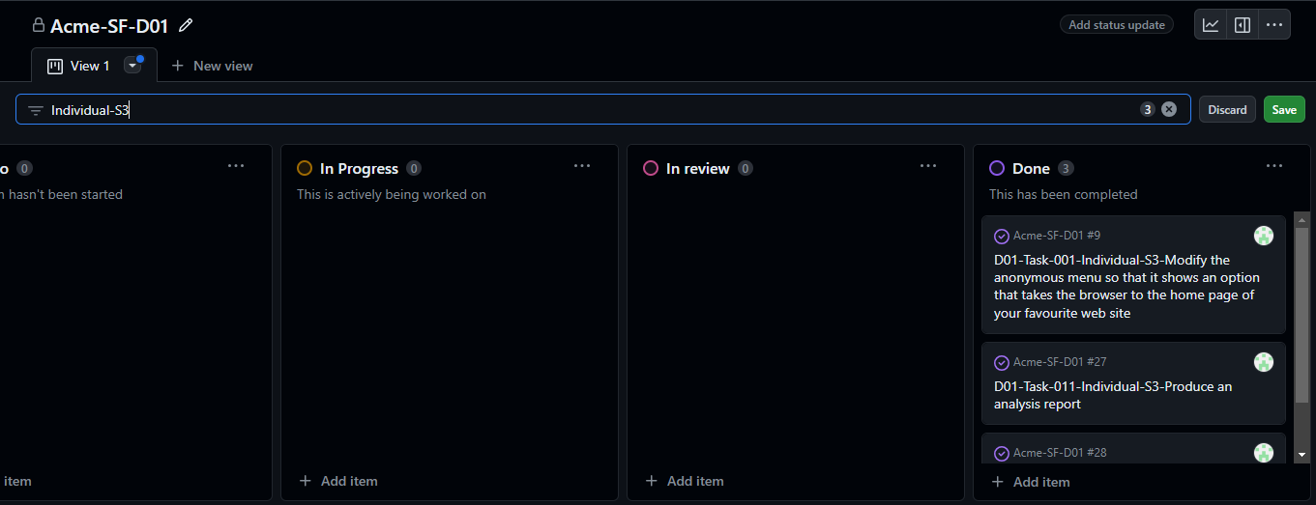

**4.1.3. Budget**

**Breakdown by tasks**

|  |  |  |  |  |  |  |
| --- | --- | --- | --- | --- | --- | --- |
| **Task** | **Role** | **Salary per minute** | **Estimated time (minutes)** | **Estimated Cost (€)** | **Real Time(minutes)** | **Real Cost(€)** |
| Task-001 | Developer | 0,33 | 10 | 3,3 | 6 | 1,98 |
| Task-011 | Analyst | 0,5 | 30 | 15 | 26 | 13 |
| Task-012 | Analyst | 0,5 | 40 | 20 | 29 | 14,5 |
| Task-001T | Analyst | 0,5 | 15 | 7,5 | 8 | 4 |
| Task-002T | Tester | 0,33 | 5 | 1,65 | 3 | 0,99 |
| TOTAL |  |  | 100 | 47,45 | 72 | 34,47 |
|  |  |  |  |  | Amortization | 11,49 |

A straight-line amortization over 3 years has been considered. Also, the work hour costs for a manager or analyst role have been considered as €30, while for all other roles, it has been set at €20.

**4.2.** **Progress chapter**

**4.2.1 Progress records**

|  |  |  |
| --- | --- | --- |
| **Member** | **Performance** | **Action Taken** |
| Sevillano Barea, Alejandro | Punctuality and quality - Good | Does not apply |
| López Cubiles, Antonio José | Punctuality and quality - Good | Does not apply |
| Díaz Ordoñez, Pablo | Punctuality and quality - Good | Does not apply |
| Nieto Vicioso, Javier | Punctuality and quality - Good | Does not apply |

**4.2.2. Conflicts**

I have not encountered problems or conflicts during the development of this deliverable.

**4.2.3. Costs comparison**

**Estimated time:** 100 min (1h 40 min)

**Actual time:** 72 min (1h 12 min)

**Difference:** +28min

**Estimated Cost:** 47,45€

**Actual Cost:** 34,47€

**Difference:** 12,98€

# 5. Conclusions

After seeing that the development time and the costs of this deliverable have been smaller than the predicted ones, and acknowledging that no problems were found, we can affirm that this has been a rather easy deliverable. In the future, I don’t expect the deliverables to be so easy, but this fresh start gives me hope that I will perform properly.

# 6. Bibliography

"08 Annexes.docx" - Material provided in the DP2 subject at the University of Seville.Principio del formulario